Department of Computer Science and Engineering
2025-2026
Odd Semester


DATA STRUCTURES AND ALGORITHMS-3
(25CS2103E)

TradeOptima: An Algorithmic Trading Platform

V. Rohan Jacob – 2520030558
J. Sai Satyan – 2520030088
K. Shankar - 2520030063

COURSE INSTRUCTOR
Dr. J Sirisha Devi
Professor
Department of Computer Science and Engineering
TradeOptima: An Algorithmic Trading Platform

Overview of the Case Study
A real trading platform is never built around a single algorithm. It must search text quickly, make optimal decisions under real-world constraints, route orders efficiently across multiple venues, select a portfolio under a budget, and estimate risk before committing capital. Each of these is a distinct computational problem belonging to a different advanced-algorithm family, and no single technique taught in an introductory data structures course solves all of them.
TradeOptima is a case study in exactly this: a single Java platform built from five hand-built subsystems, each corresponding to one module of the DSA-3 syllabus — string algorithms, dynamic programming, network flow, NP-hard approximation, and randomized algorithms. Every algorithm is implemented from first principles, with no use of java.util anywhere in the source, so that each data structure and each algorithm is a direct application of course material rather than a library call. The platform is exercised against real historical equity data (AAPL, MSFT, IBM, and SBUX closing prices, 2007–2016) alongside synthetic news and order-book fixtures, so that each module can be demonstrated on data that behaves like a real market rather than contrived textbook input.

Module-by-Module Case Study

1. Module 2 — Ticker and News Search (String Algorithms)
This subsystem answers two kinds of queries: exact multi-pattern search across a stream of news headlines (using Aho-Corasick, so every ticker is matched in a single pass over the text), and fuzzy company-name lookup using edit distance, for cases where a user query is misspelled or abbreviated.
Example — fuzzy ticker lookup
Query: "infsys" (edit distance threshold = 2)
Result: INFY (edit distance = 1)

Query: multi-pattern scan of a headline batch
Result: RELIANCE mentioned 2x, HDFCBANK mentioned 1x, WIPRO mentioned 1x
In the full pipeline, this module feeds Module 5: the number of same-day news mentions for a ticker contributes to that ticker’s selection score, so a spike in headline coverage can influence which assets are shortlisted for the portfolio that day.

2. Module 3 — Constrained Trade Optimizer (Dynamic Programming) — Core Subsystem
Given a price history, this subsystem computes the maximum profit achievable under three simultaneous constraints: a maximum number of trades (k), a fixed fee per completed trade, and a mandatory cooldown period after every sale before a new purchase is allowed. The algorithm models the trader as a finite-state machine — Idle, Holding, and Cooldown — and solves the recurrence with dynamic programming, then backtracks through the DP table to reconstruct the exact sequence of buy and sell decisions, not just the final profit figure.
Example — AAPL full-history optimization (2007–2016, 3 trades, $0.50 fee, 1-day cooldown)
BUY 2009-01-20 @ 10.35 | SELL 2012-09-19 @ 93.29 | net 82.44
BUY 2013-04-19 @ 52.43 | SELL 2015-05-22 @ 130.67 | net 77.74
BUY 2015-08-24 @ 102.13 | SELL 2015-11-03 @ 121.39 | net 18.76
Full-history hindsight optimum = $178.94 across 3 trades
Ledger legal: true (independently re-verified against the constraints)
This is the most heavily validated subsystem: its output has been checked against a brute-force reference across 3,000 randomized test cases, and at the largest specified scale — 100,000 price points with 1,000 permitted trades — the optimizer completes in 290.7 milliseconds, comfortably inside the 2-second target set for the project.

3. Module 4 — Cross-Venue Order Router (Network Flow)
When a selected asset must actually be bought, it may be available at slightly different prices across multiple venues (exchanges, dark pools, etc.), each with limited depth at each price level. This subsystem models the problem as a minimum-cost flow network and uses the Ford–Fulkerson family of algorithms (with Hopcroft–Karp for the bipartite-matching special case) to split an order across venues for the lowest total execution cost.
Example — routing a 1,000-share order
Order 1: 350 shares @ 100.06 on NSE
Order 1: 100 shares @ 100.03 on BSE
Order 1: 150 shares @ 100.00 on DARK
Order 2: 300 shares @ 100.01 on NSE
Order 2: 100 shares @ 100.03 on BSE
Total filled: 1,000 shares, total cost $100,030.00
The router’s output feeds directly back into the day’s realized cost for Module 5’s selected basket, so a poorly routed order directly worsens the platform’s reported performance for that day.

4. Module 5 — Budget-Constrained Portfolio Selector (NP-Hardness and Approximation)
Choosing which assets to buy under a fixed budget, to maximize a combined score of trading profit and news relevance, is a 0/1 knapsack problem — NP-hard in general. Rather than solving it exactly at scale, this subsystem offers two approximation strategies: a greedy heuristic with a provable 2-approximation guarantee, and a fully polynomial-time approximation scheme (FPTAS) that trades a small, tunable error margin for near-optimal results.
Example — portfolio selection under a $5,000 budget
FPTAS (epsilon = 0.05): value 353.00, cost $5,000.00
Selected: INFY, RELIANCE, HDFCBANK, WIPRO
Greedy 2-approximation: value 332.00, cost $4,600.00
Both results are checked against an exact dynamic-programming oracle on small instances to confirm the FPTAS stays within its promised (1 − ε)·OPT bound and the greedy solution never falls below OPT/2.

5. Module 6 — Monte Carlo Risk Engine (Randomized Algorithms)
Before committing to a selected basket, the platform estimates downside risk using randomized simulation: a reservoir sampler maintains a uniform random sample of historical returns from a data stream of unknown or unbounded length, and a Monte Carlo / bootstrap procedure uses that sample to estimate Value-at-Risk (VaR) and Conditional Value-at-Risk (CVaR) at a chosen confidence level.
Example — 10-day, 99% risk estimate on a $1,000,000 basket
Reservoir: streamed 99,999 returns, kept a uniform sample of 5,000
Parametric VaR: $8,235.71 (CVaR $9,416.82)
Bootstrap VaR: $8,122.36 (CVaR $9,176.31)
A negative VaR, were one to occur, would indicate an expected gain rather than a loss at that quantile — the engine reports this correctly as part of its self-tests.

ALGORITHMS USED

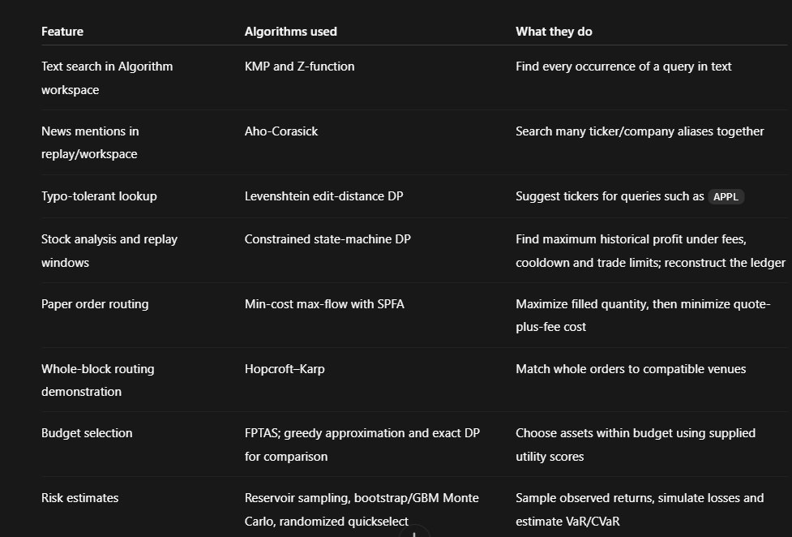
CODE
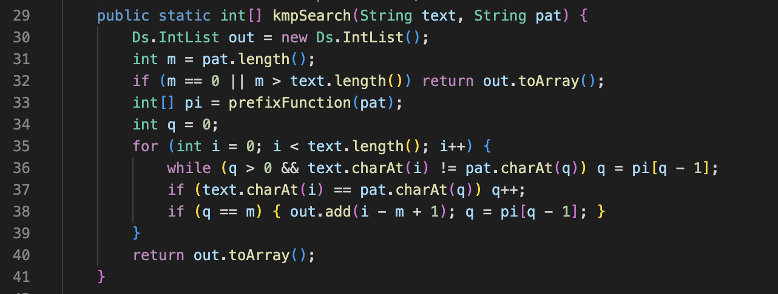

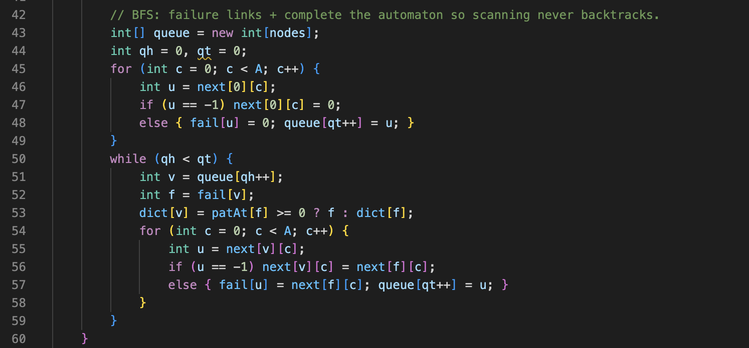

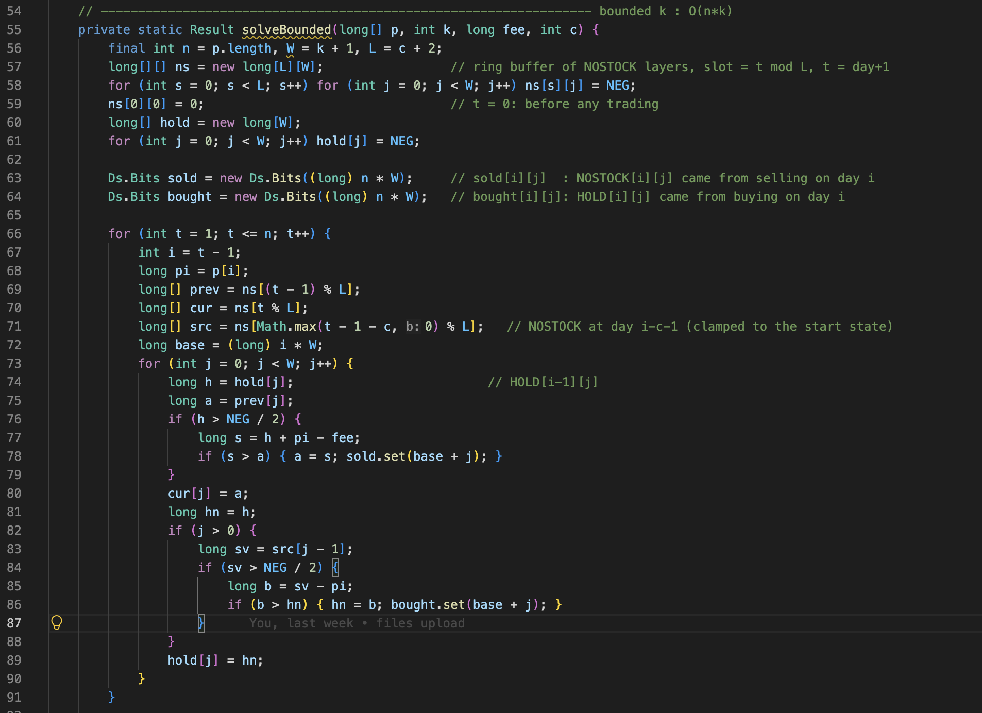
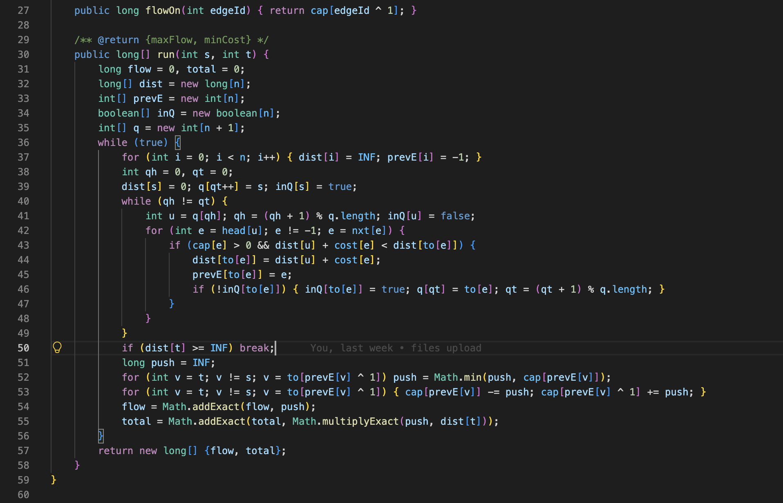
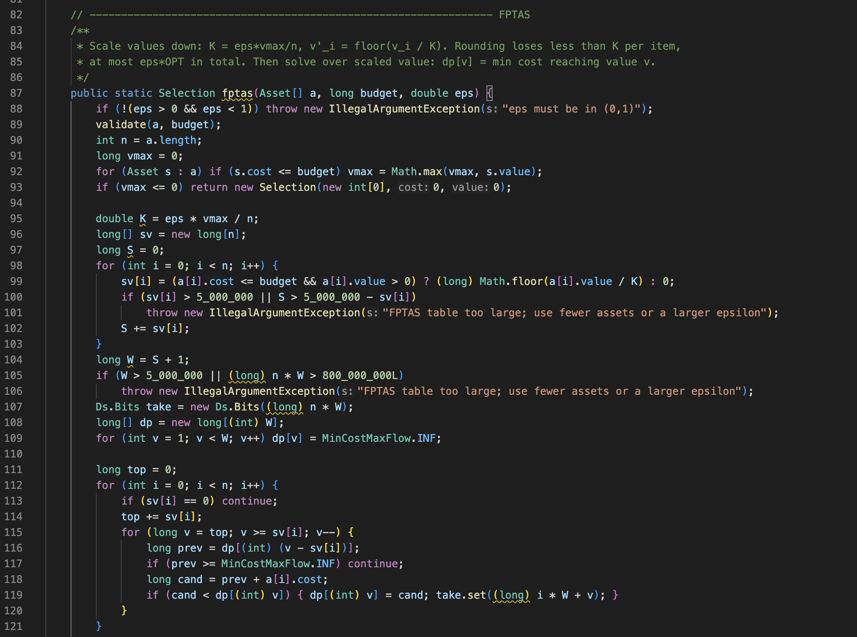

RESULTS
